 Git Challenges
Resolve Merge Conflicts
- Create a merge conflict intentionally (two users editing the same line).
- Resolve the conflict and push the changes
Meaning: A merge conflict happens when Git tries to combine two branches, but the same part of the same file was changed differently in both branches — and Git cannot decide which version to keep.
if two branches modify the exact same lines of code in a file, Git cannot determine which version to keep without human intervention.
(to be done on branch 1)
Step 1: created a file using touch filename
Step 2: inserted the data using notepad++
Step 3: using git add . command added the files to tracked or staged area
Step 4: committed the files using git commit
Step 5: check the status of file
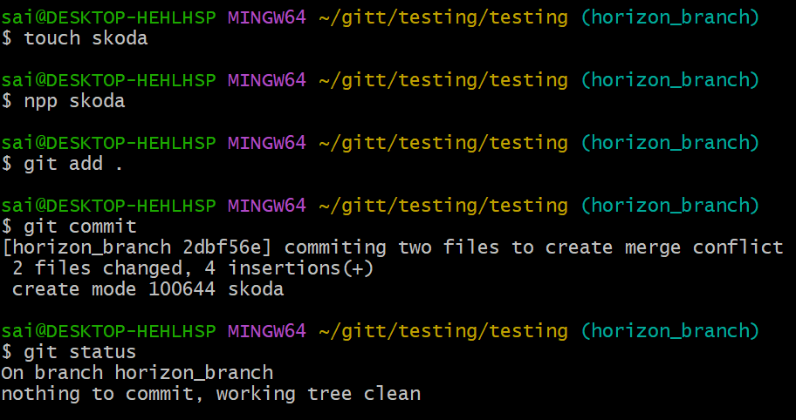

Step 6: change the branch using git checkout command
Step 7: do the above same in another branch with same name and contents
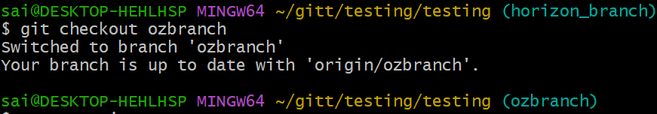
Step 8: listed the files to verify the file and checked the status and verified
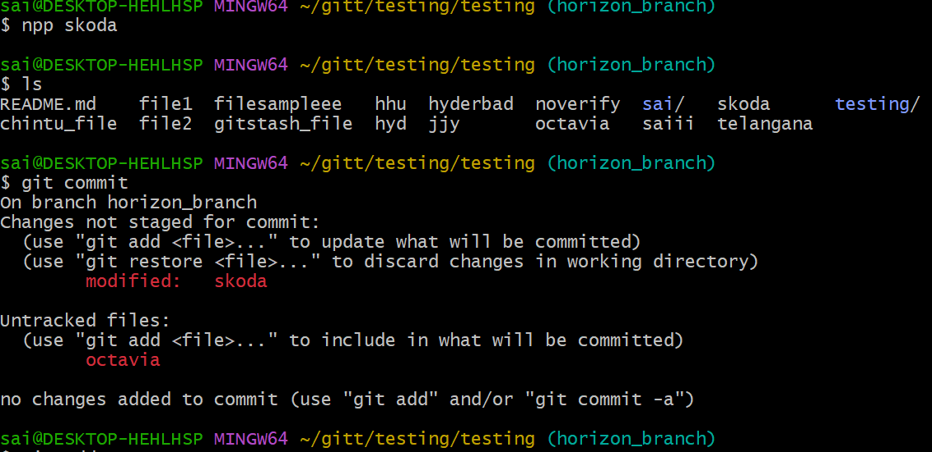
Step 9: commited the files using git commit
Step 10: using git merge command to merge the files and caught with conflict
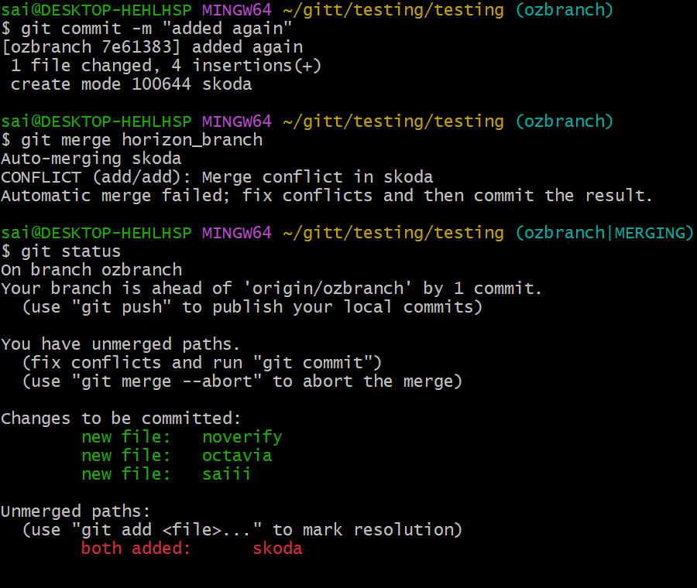

Step 10: again edited,added,committed the files after merge conflict
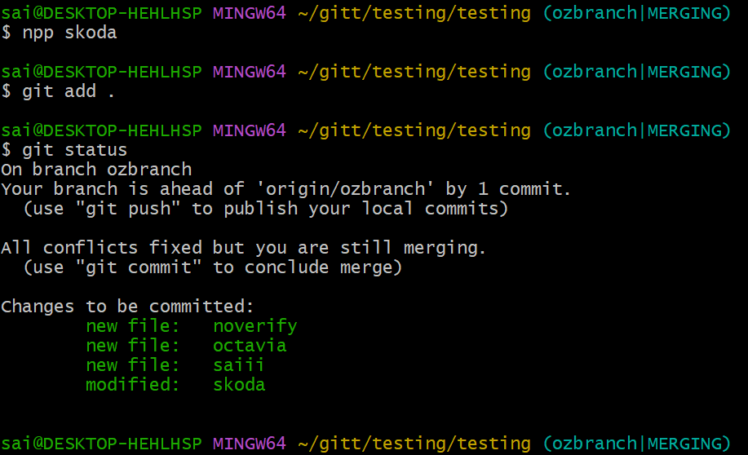

Step 11: USING git merge command to merge the files and merge was successfull
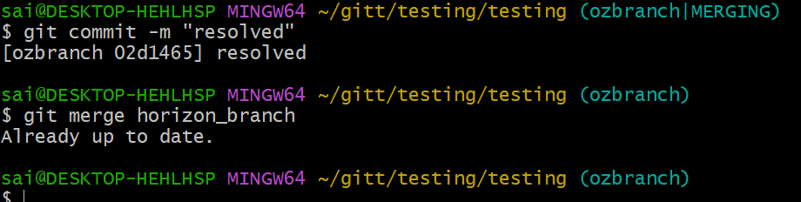

- Recover Deleted Branch
  - Delete a local branch and then recover it using the reflog.
Step 1: checked the list of available branches using git branch –list command
Step 2: using git branch -D command to forcefully delete the branch
( {-D} for force delete a local branch if not completely merged)
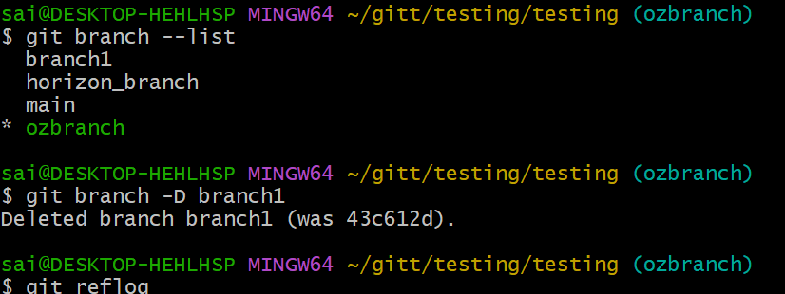
Step 3: then created a branch with same using same commit number
Step 4: Then changed the branch to verify
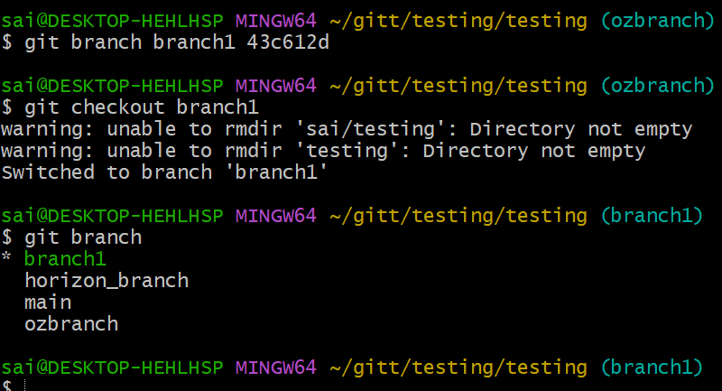

- Undo Wrong Push
  - Push a wrong commit to GitHub, then undo it without losing history.
Step 1: added the files and checked using status commands
Step 2: commited the files using git commit -m command and noted the commit id
Ex. (8f42720)
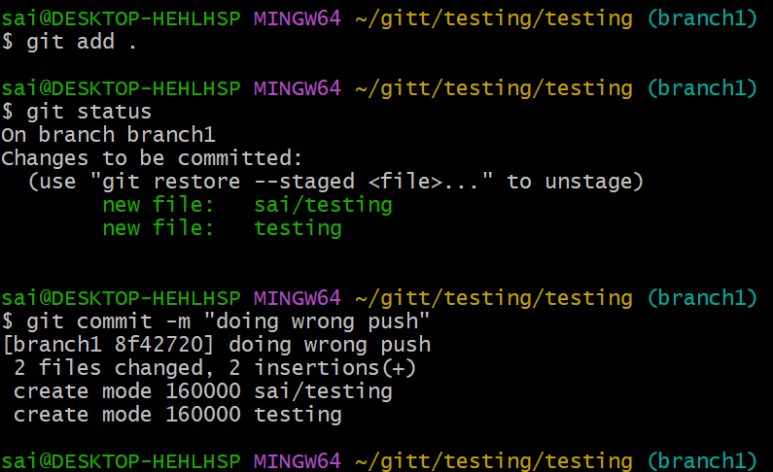
Step 3: using commit number executed git revert command to undo the push
And verified the status
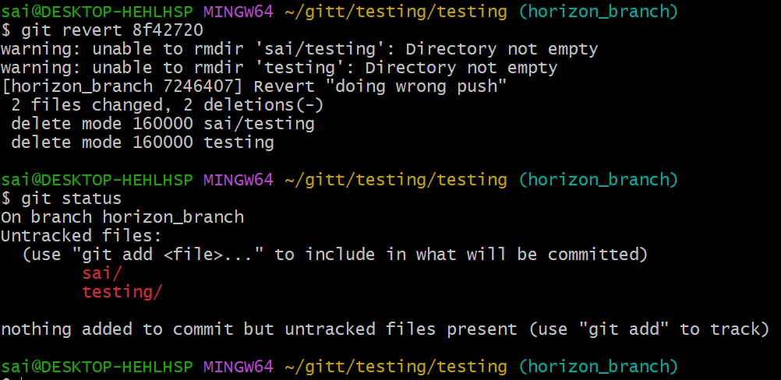
- Amend a Commit
- Make a commit, then add a missing file to it using git commit --amend
Step 1: added the files to staged area using git add . command
Step 2: commited the files using git commit -m command
Step 3: added the file using touch command
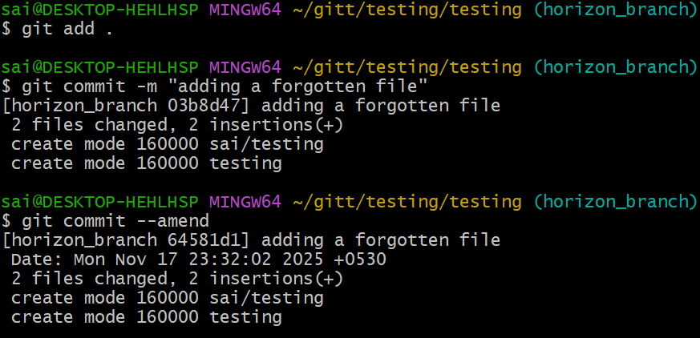
Step 4: again added the files to tracked
Step 5: using git commit –amend you will be redirected to insert mode then add the file name and file type to add your file
Step 6: you can see previous commit has Files 3 files
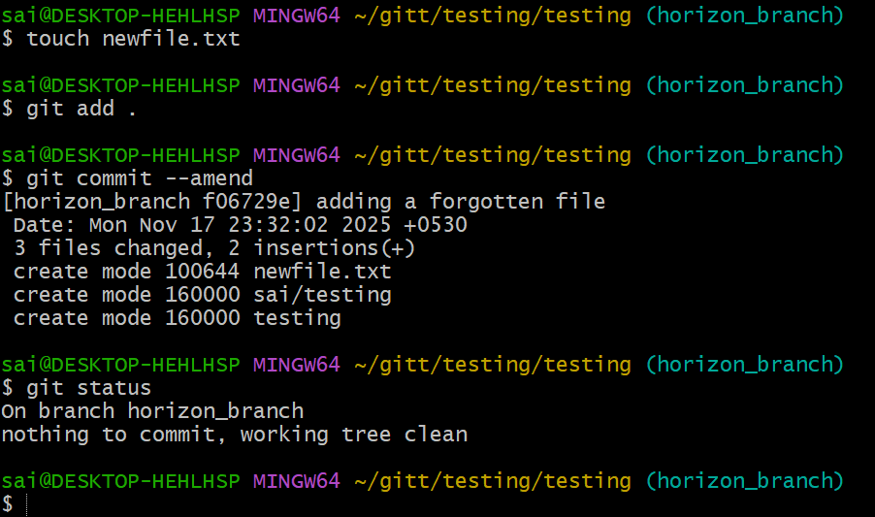

- Cherry-pick a Commit
Take a specific commit from one branch and apply it to another branch.
Step 1: checking the last logs of commits
Step 2: changing the branch to other using git checkout command
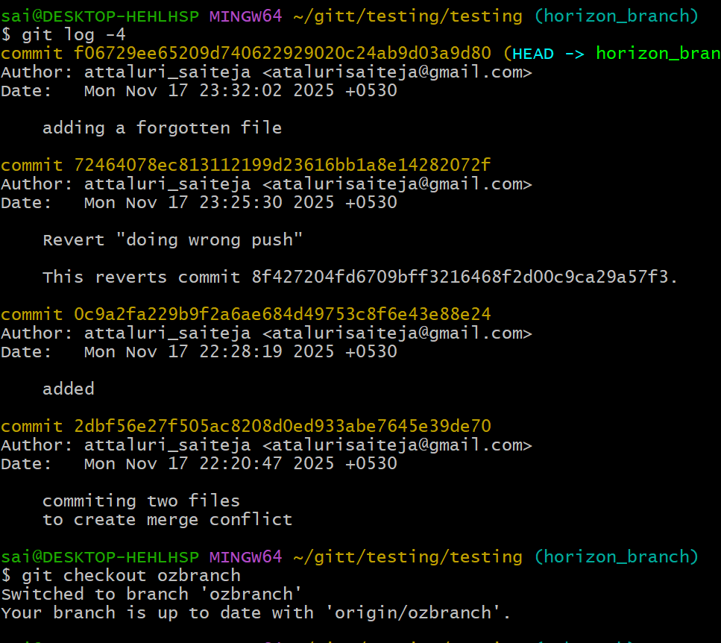
Step 3: using command cherry pick and commit number to copy a single commit from logs
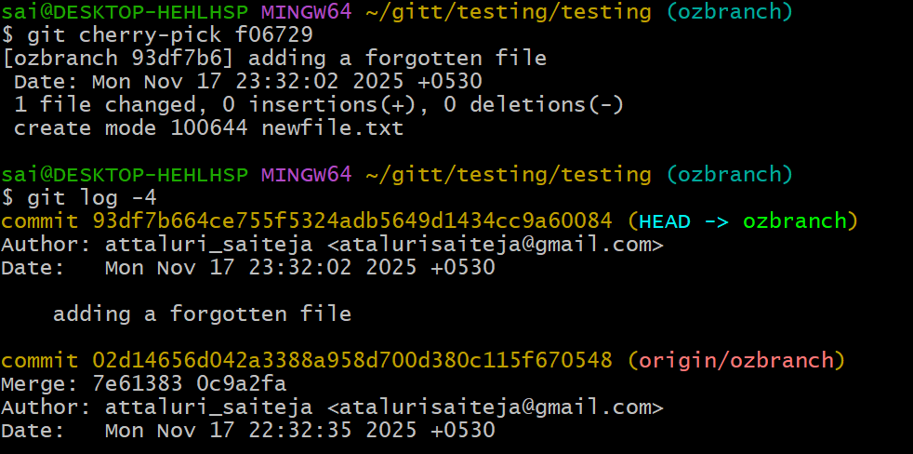

- Interactive Rebase
  - Reorder and squash multiple commits into a single clean commit.
Step 1: got the commits in single line using git log –oneline command
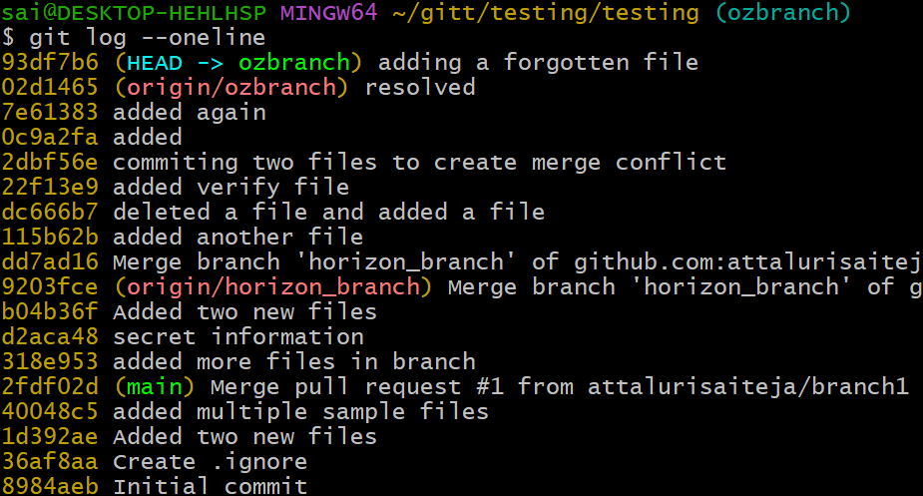
Step 2: using git rebase -I head~5 command to list last five commits
Step 3: you will be redirected to vi/notepad++ editor in that replace the pick with squash from second commit as shown in below picture
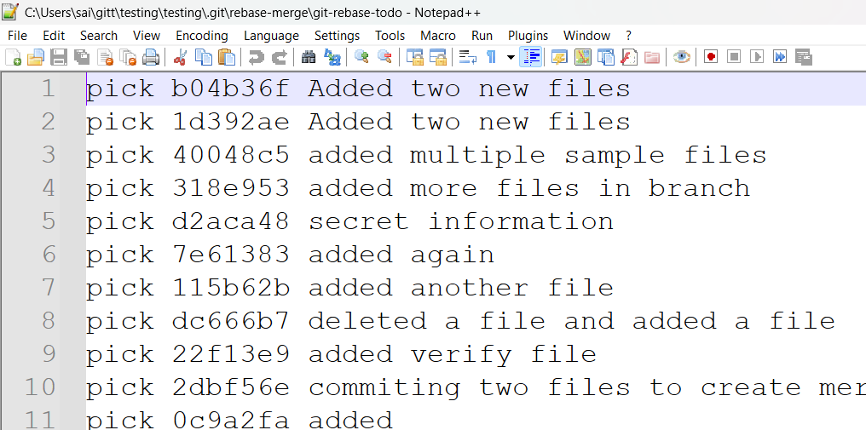
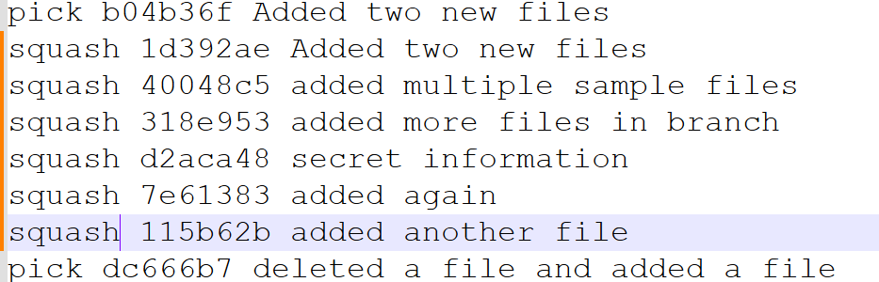
Step 4: then save the file
Step 5: check the log again then it will be in a single commit
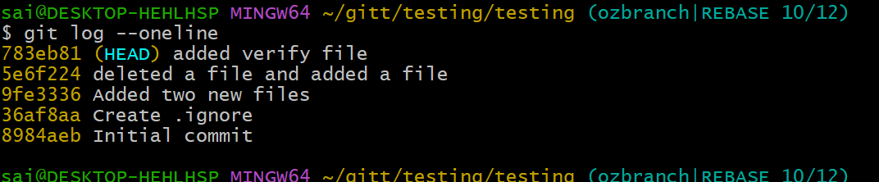

- Tagging & Release
  - Create a version tag (v1.0), push it to GitHub, then delete and restore it.
Step 1: created a tag using git tag command
Step 2: push it to central repo using command git push
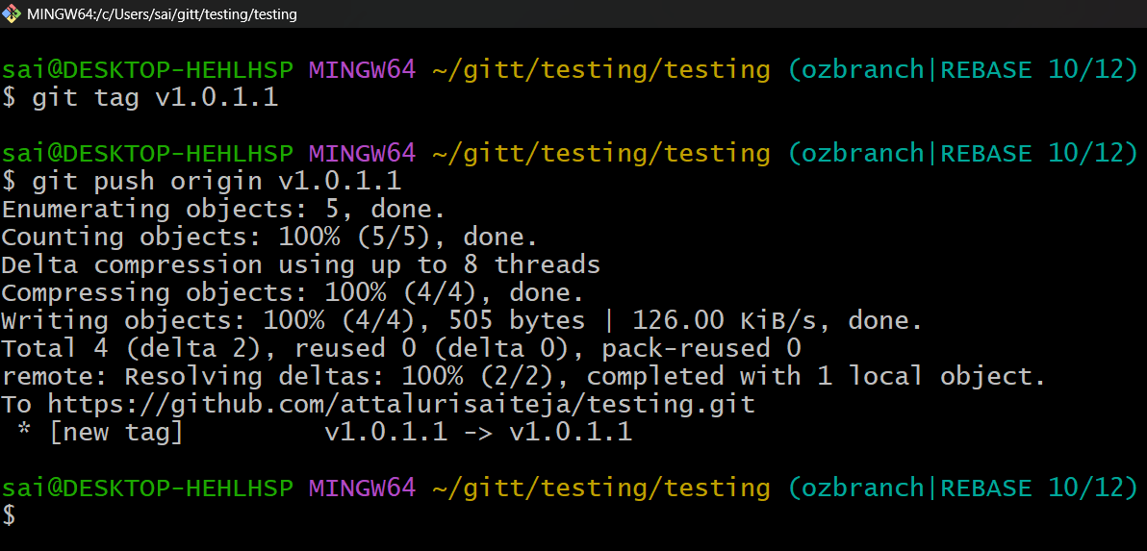
Step3: verifying in central repo
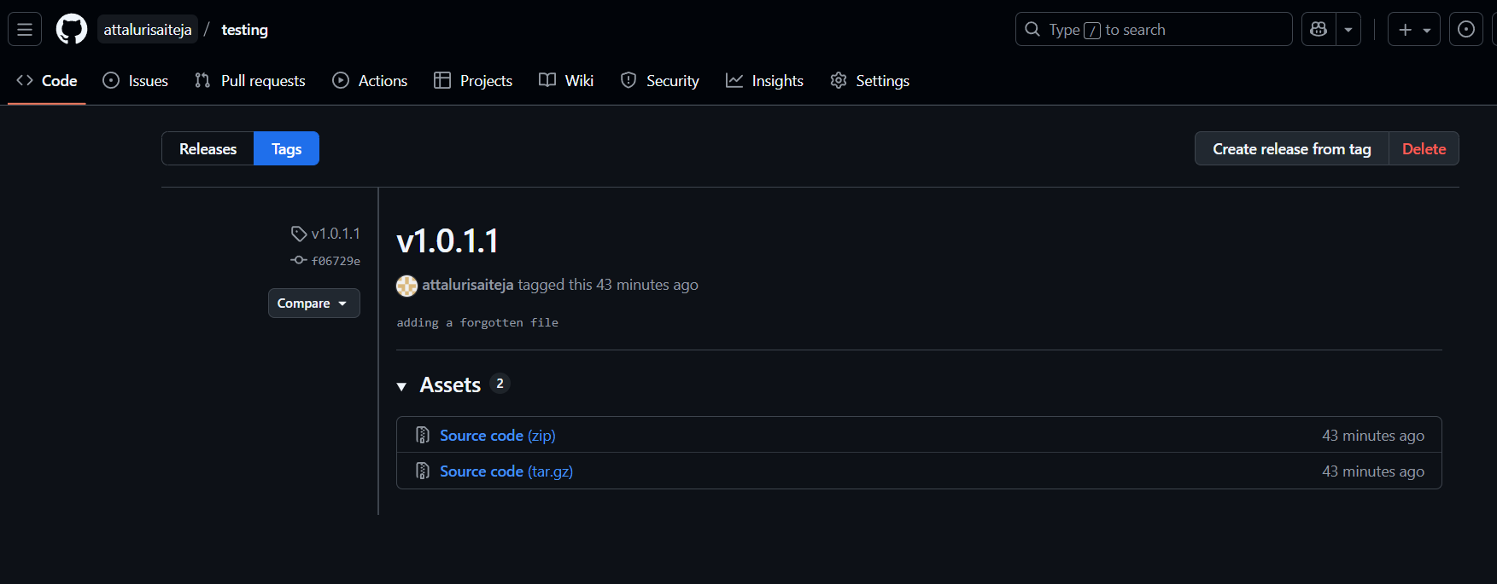
Step 4: deleted a tag using git tag -d v1.0.1.1
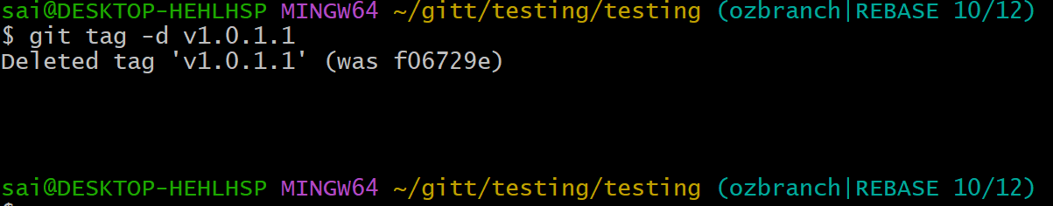

Step 5: restored a deleted tag using git tag commit number
Step6 : used git tag to list the tag available.
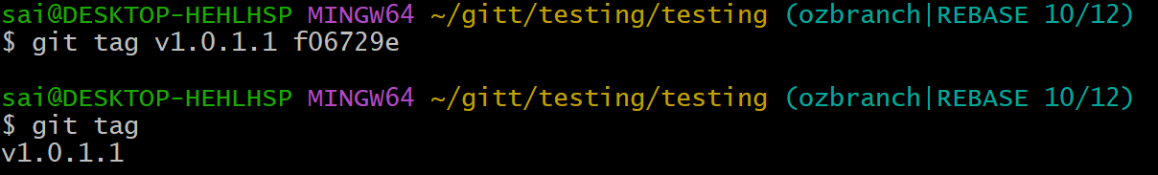
- Clone with Sparse Checkout
  - Clone only a subdirectory of a repo using sparse checkout.
Clone the repository, but download and check out only the folders you want, not the entire project.
Because cloning big repos (GBs of files) is slow. Sparse checkout:
- Saves time
- Saves disk space
- Lets you treat a subfolder like a lightweight repo
Step 1: initiated git checkout sparse using command git sparse-checkout init command
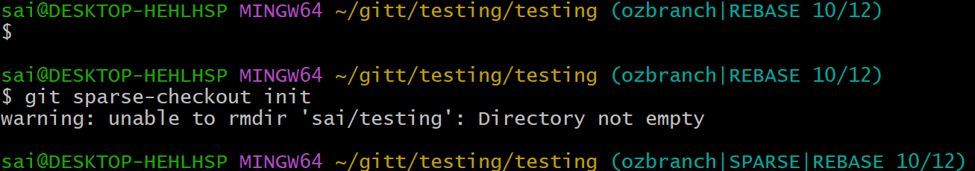
Step 2: set the directory
Step 3: got the list using git checkout list
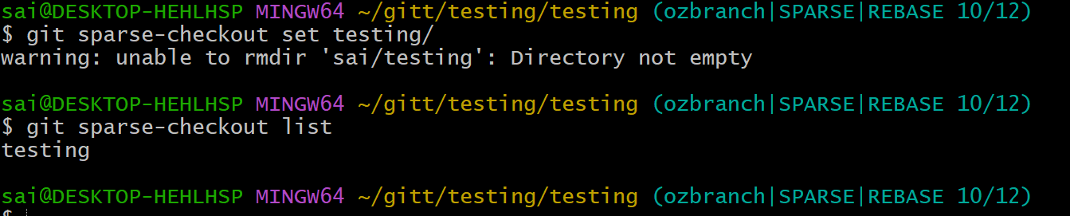

- Reset vs Revert Challenge
  - Demonstrate the difference between git reset --hard and git revert in a repo.
git reset
MOVES the branch pointer backward and optionally changes your working directory and staging area.
It rewrites commit history.
And doesn’t asked for editing or writing commit message
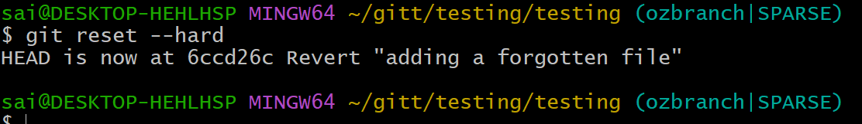
git revert
CREATES a NEW commit that undoes the changes of a previous commit.
Asked for writing commit message
Checked the logs using git log -5 command to see 5 logs
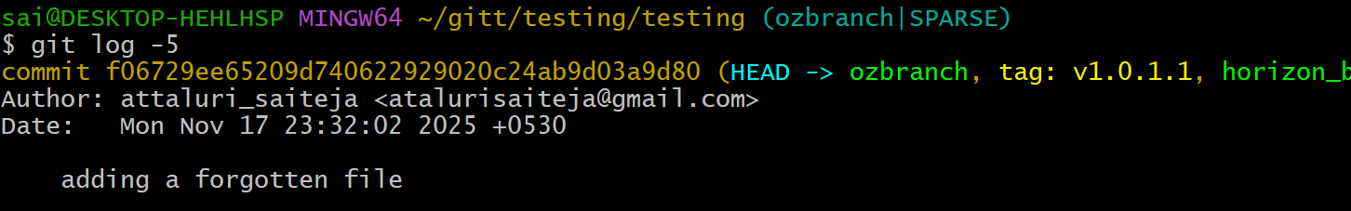
Using git revert command to edit the commit
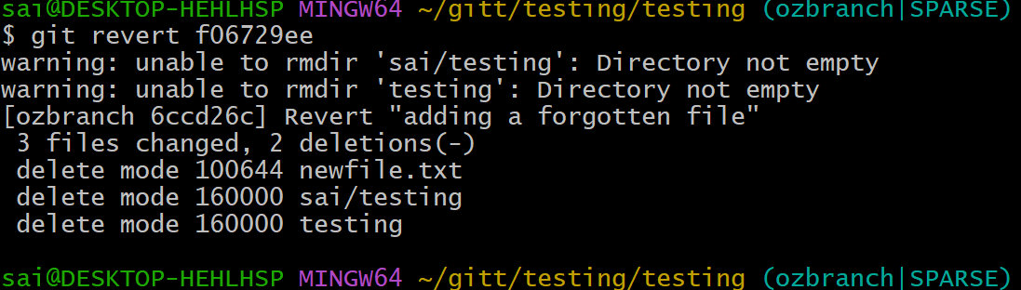

- Detached HEAD Challenge
  - Checkout a specific commit (detached HEAD state) and create a new branch from it
Step 1: checked the logs using git log –oneline command.
Step 2: change the branch using a commit number from previous logs
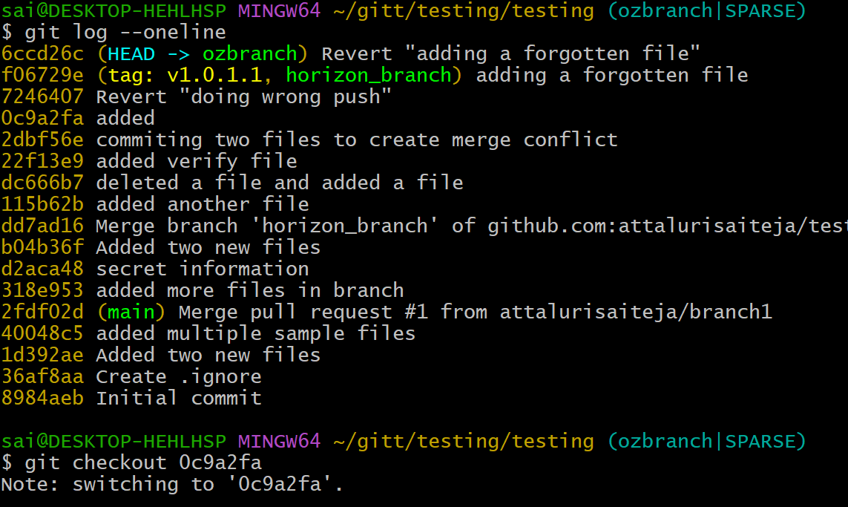
Step 3: switched the branch using git checkout command
Step 4: got the branches list using git branch
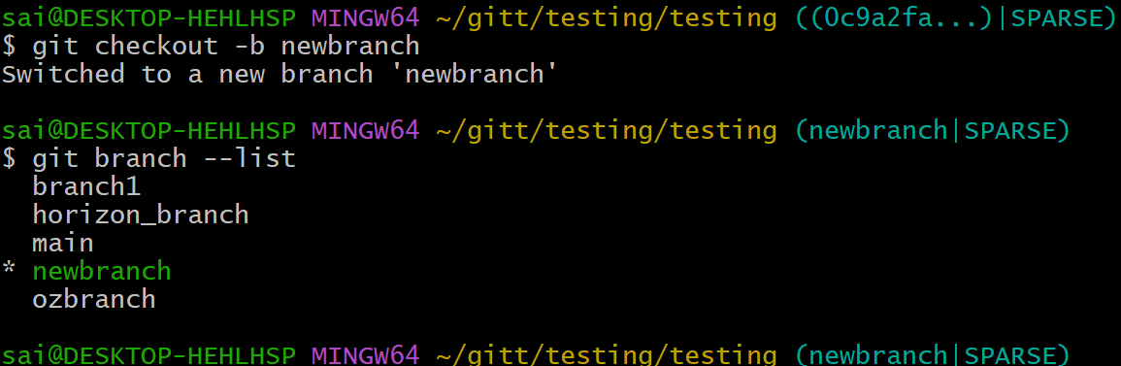

- Squash Merge vs Rebase Merge
  - Show the difference between squash merge and rebase merge with evidence.
- Squashing: All the commits on the feature branch are combined into a single, new commit. This new commit represents the cumulative changes introduced by the entire feature branch.
- Merging: This single, squashed commit is then merged into the target branch.
Step 1: using command git merge branch –squash to merge
Step 2: committed using git commit -m
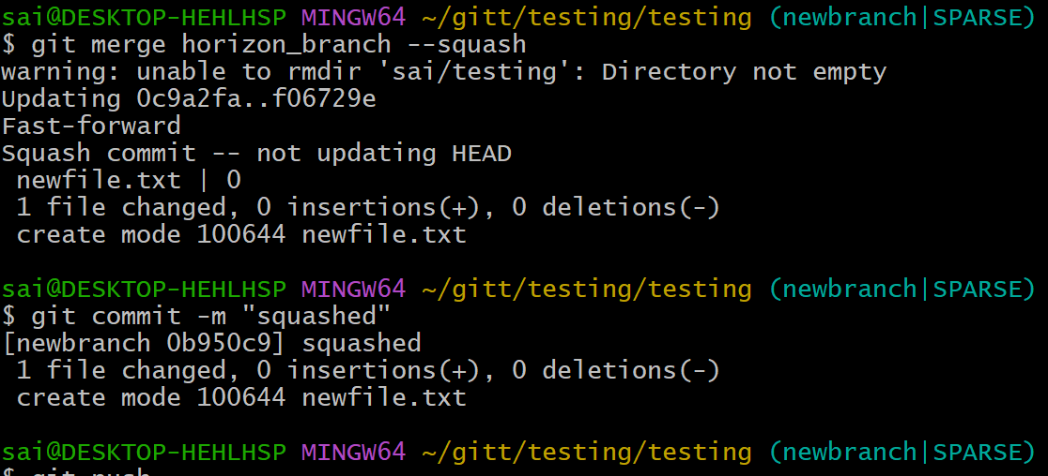
Rebase Merge (Regular Rebase + Fast-Forward Merge)
A rebase merge rewrites the feature branch commits to sit on top of the target branch, then merges (fast-forwards).
- Keeps all commits from the feature branch
- History becomes linear (no merge commit)
- Great for clean, understandable logs
- Works well with small, well-organized commits

Step 3: using command git rebase to rebase and update
Step 4: using command git checkout main to switch the branch
Step 5: merged the branch from main to horizon_branch
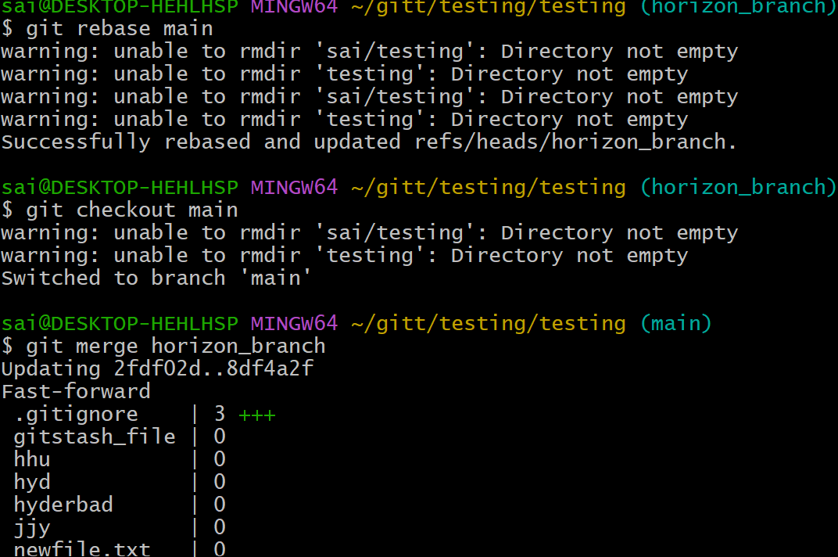

- Fork & Pull Request Workflow
  - Fork a repo, make a change, and submit a pull request to the original repo.
The Git fork and pull request workflow is a common method for contributing to open-source projects or collaborating on projects where direct write access to the main repository is not granted. This workflow involves creating a personal copy of a repository, making changes, and then proposing those changes back to the original project.
Step 1: created a directory using mkdir
Step 2: and changed to directory using cd
Step 3: copies a repository link using fork in github and clone it inside local machine cloned open source project from public archive
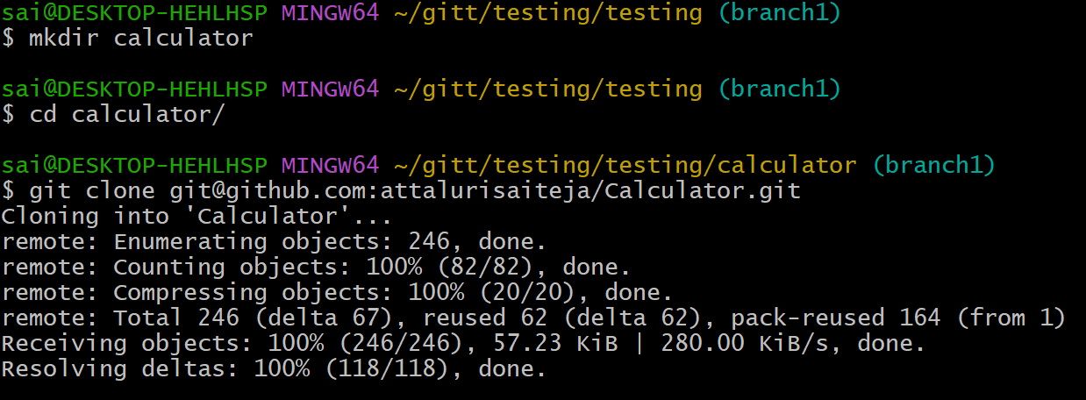
Step 4: pull the info from repo to local
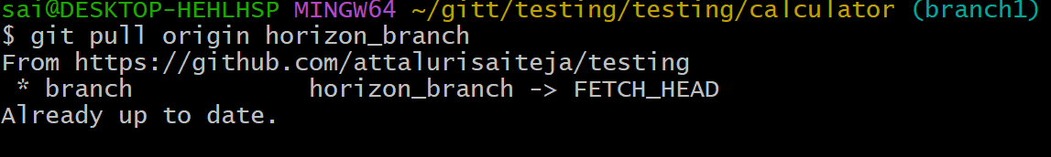
Step 5: added the remote url in local machine and verified
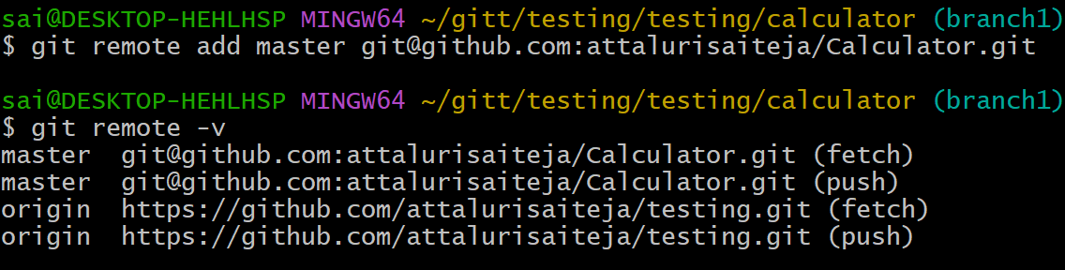

Step 6: changed the directory to repo (calculator) and viewed the contents
(now im inside the repo and having access to modify)
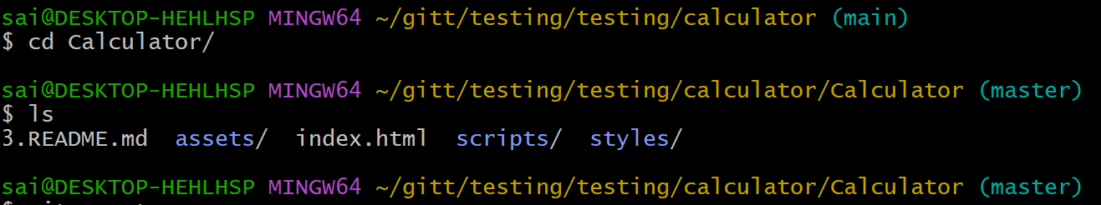
Step 7: accessed the index.html and edited using npp and pushed again to central repo
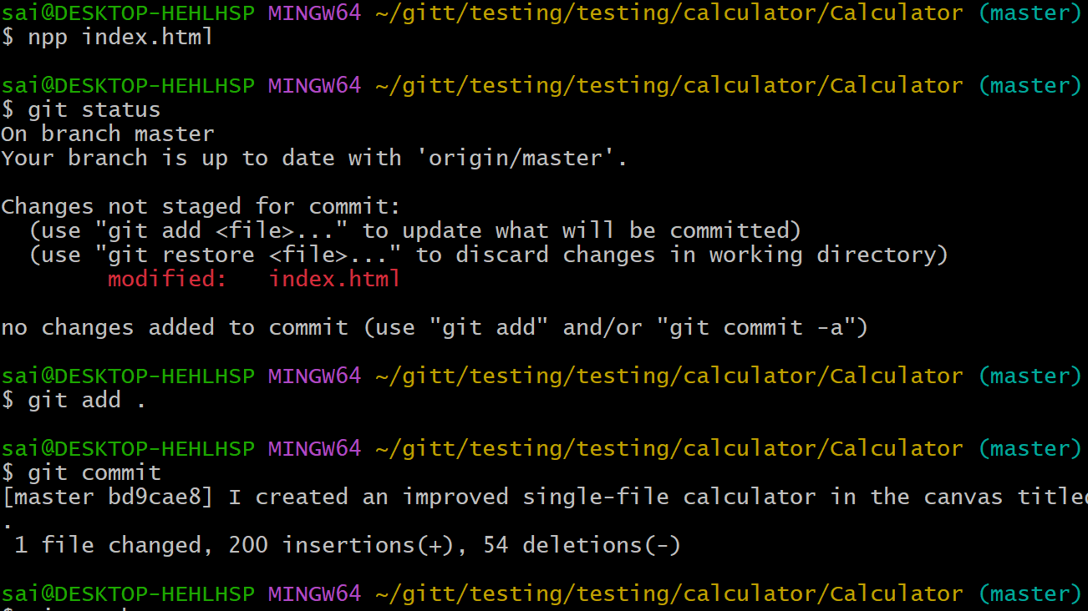
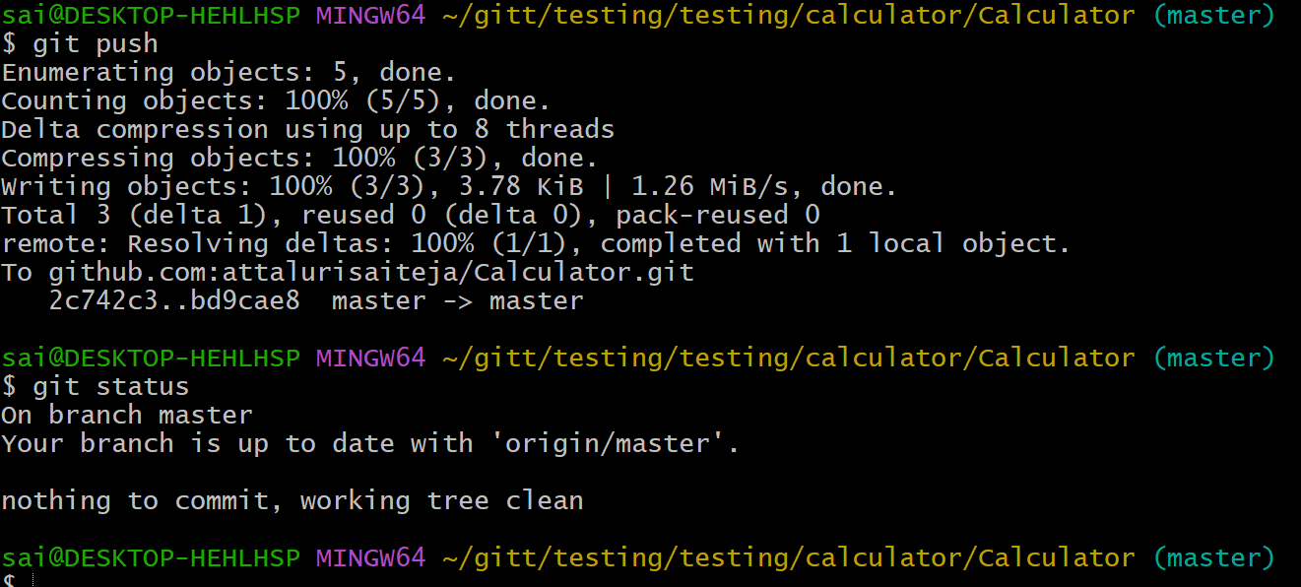

In central repo
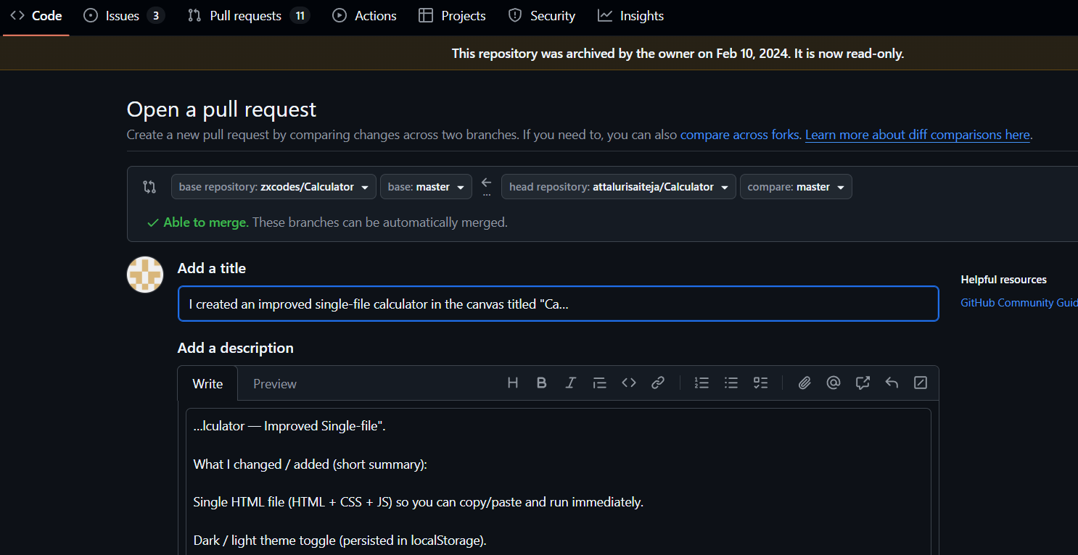

- Recover lost commit
Commit something, reset hard, and then recover it using git reflog
Step 1: added a commit and deleted a commit using git reset –hard head~1 and checked logs
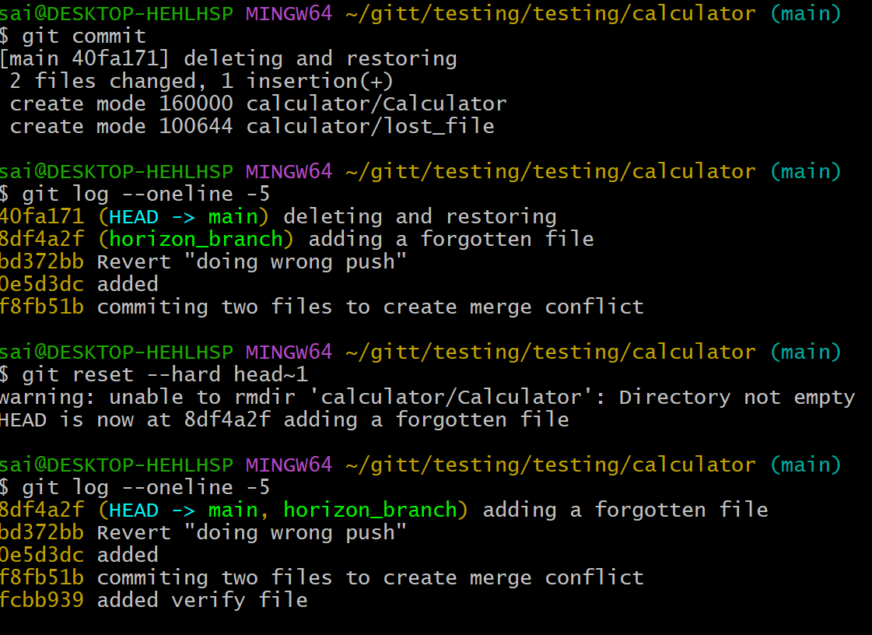
Step 2: restored the commit using commit id and recovered the commit and checked logs
Command : git reset –hard commit id
